THE COMPOST-DRILL  
  
Size: (for 7-8 people)  
Material:(Wood, plastic, clay, metal, etc)  
  
Issues with composting:  
1. Needs to keep rotating, motor needs to be strong enough to spin around.  
2. Needs to keep adding materials to keep the texture and consistency  
  
Research To be done:

1. Different Methods of Composting
2. How to compost it?
3. Drainage of the compost liquid
4. Website required or not?
5. Aerobic / Anaerobic composting - is pressure generated

* Drainage  
  1. Set up flaps to open up once every few (time duration to be added)/ once a certain water weight has been reached

2. Timer to swivel open and let water drain

3. Add an extra tank below the drain (which will be open 24/7) that can be drained later after a certain weight has been reached.

* Sources of Power:  
  1. Solar (not suitable in cloudy/rainy days/ nights)  
  2. Manually operated

3. Hand Cranked battery/winded gears  
4. During rains, using the weight of rainwater/heavy winds to rotate

* Prototype 1- CAD model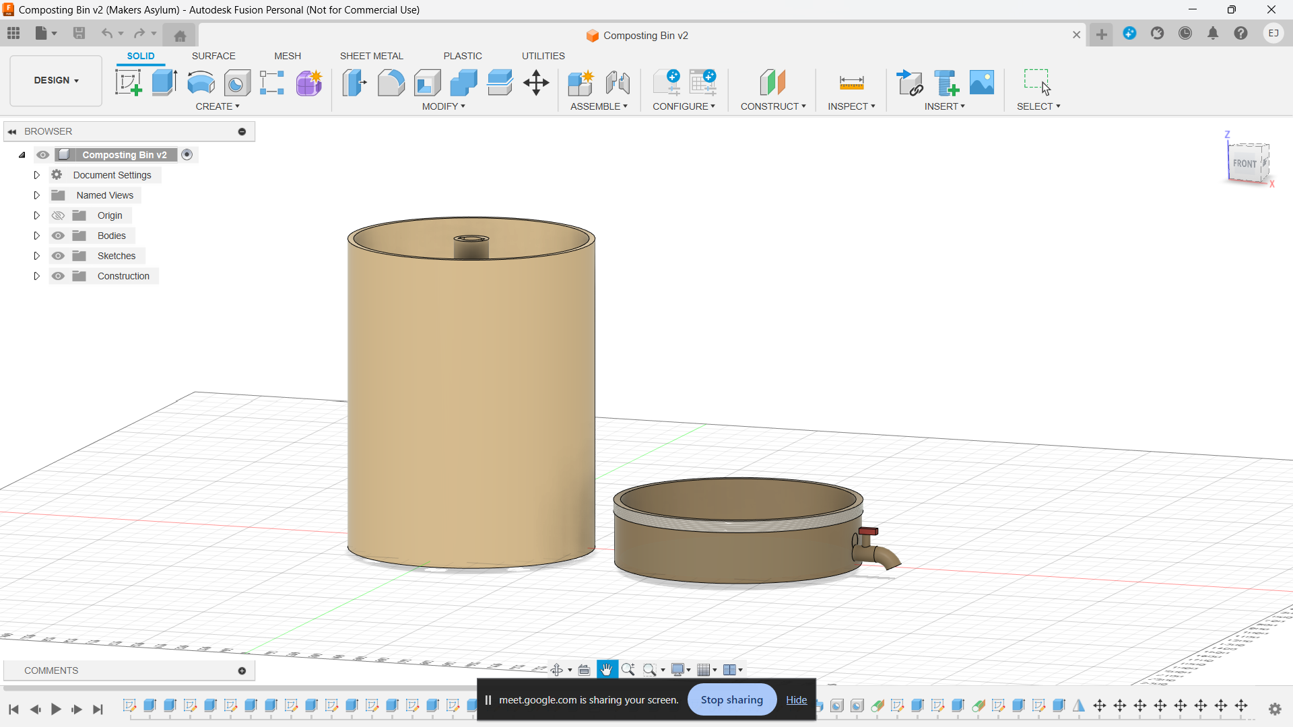
* Prototype 2- Paper prototype

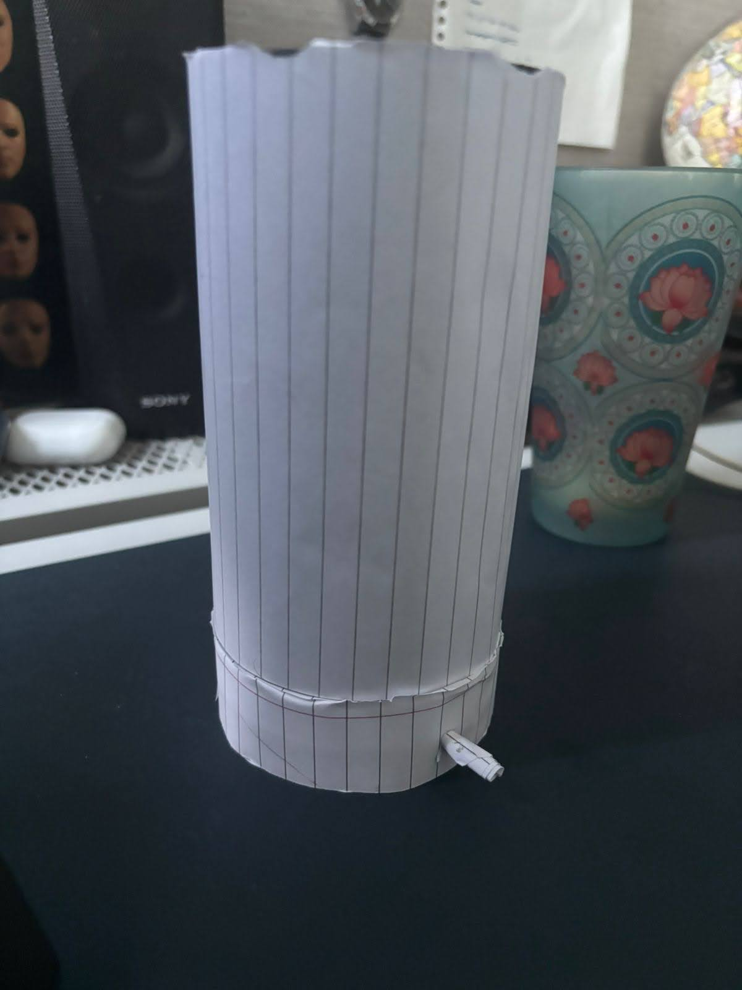

* Prototype 3 - Sun-board and a plastic container

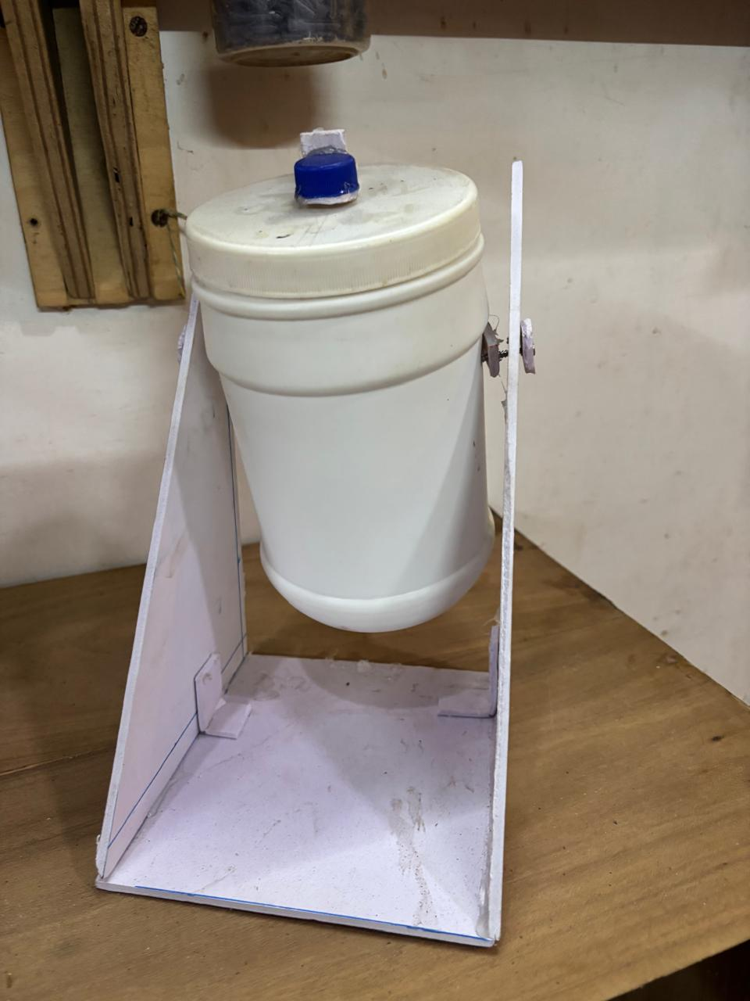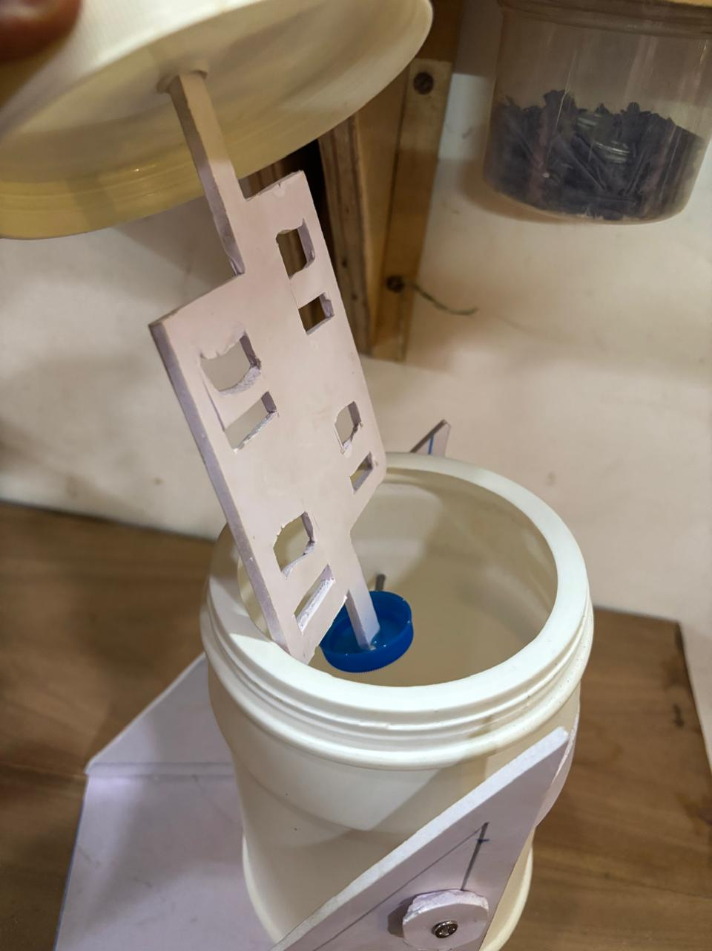

* Final Project (along with a picture of the acrylic flaps attached on the inside)

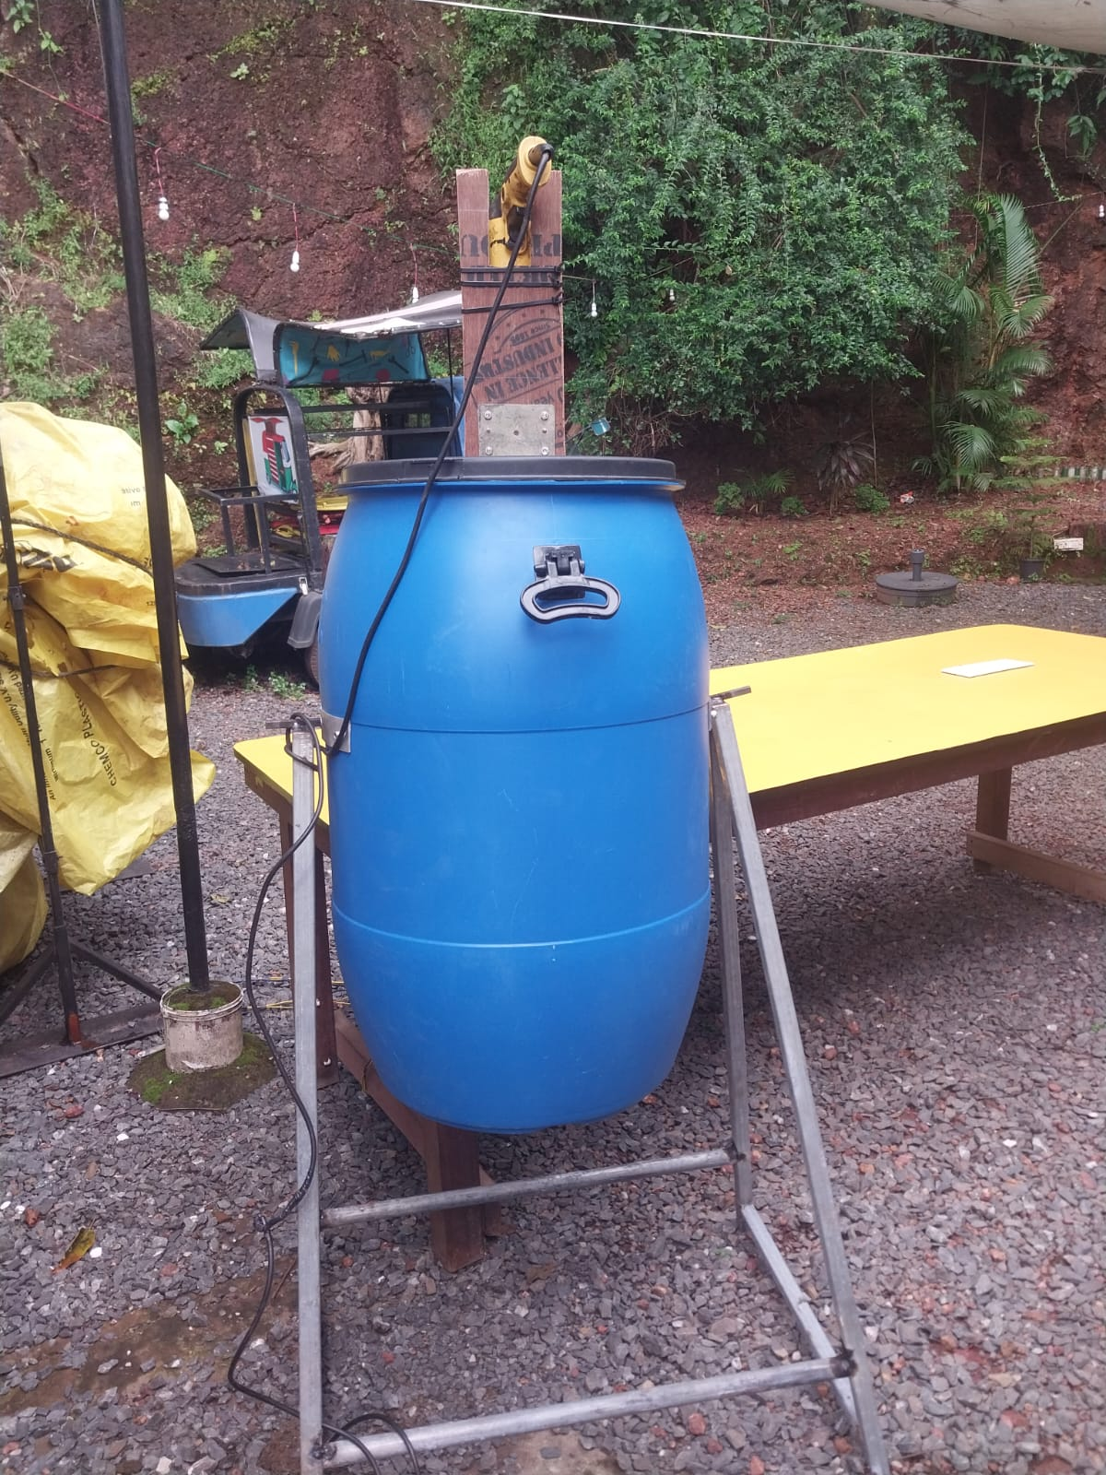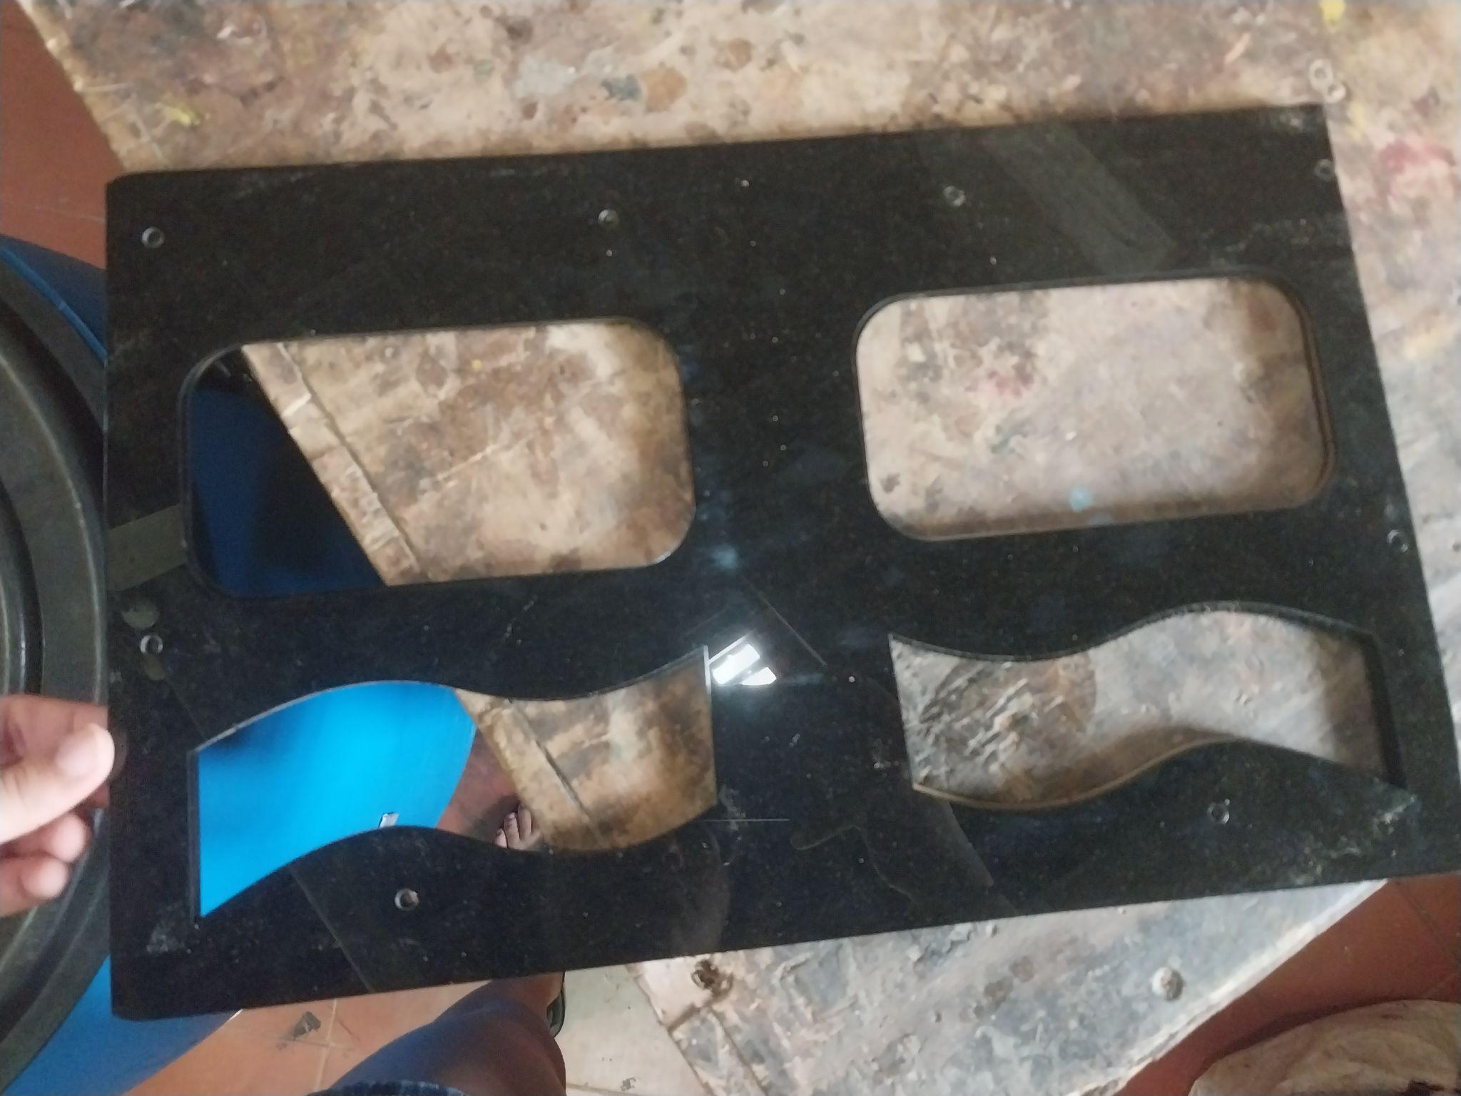

**Problem Statement**

*Mention the problem you are trying to solve or the reason behind the project*

Composting, although extremely beneficial for the Earth, is a tedious process that requires a lot of maintenance and work. To make composting easier, we developed ‘**The Compost-Drill’**

**Idea**

*A general description of your solution*

A compost bin that uses a drill-attached rotating arm with flaps to turn the compost so that it decomposes faster and with little to no manual labour through the process.

**Prototypes and rejected versions**

*Mention all the brainstorming points and different ideas discussed and the reason for selecting the final idea(add images and sketches)*

Our first prototype was made on Fusion 360, it was the ideal design of what we wanted our compost bin to be structurally without its stand.

Our 2nd prototype was a paper prototype that was made using paper and the inside of a kitchen roll’s cardboard. We used this prototype to see how the structure of the compost bin would be and where we could possibly place our motor.

Our third prototype was made using sun-board and a plastic container as a representative of our compost bin. We used the paper prototype to understand the mechanics of how our compost bin would balance on the stand.

Our original idea was to use an E-bike motor and an arduino to rotate the flaps but we didn’t have the right drivers for the motor, so we opted to use a drill instead.

**Final Project idea /Solution**

*Describe the final project idea*

A Drill-operated compost bin,made using a water barrel, with flaps made of acrylic so that the compost can be turned at regular intervals with just the press of a button, making composting easy and accessible for all.

**objectives of the project**

*State the objectives of your project precisely and distinctly*

* Make composting more efficient
* Make composting accessible for all
* Reduce human labour while composting
* Increase recycling of wet waste
* Reduce the amount of waste that reaches landfills by making it into compost

**Materials based on Block diagram**

*Create a Component list for every block and the whole project*

Stand for the compost bin (suspension mechanism)

* Square metal rods
* Welding machine
* Angle grinder

Rotating rod (inner components)

* Circular metal rod with hollow centre
* Rotating bearings
* Laser-cut acrylic flaps
* Bolts and nuts
* Angle grinder

Outer body

* 80 litre water barrel- with a lid
* Metal strips
* Bolts and nuts

Drill component

* Drill machine
* Wood block cut to shape
* Zip ties

**Logic of the complete program**

*Prepare a logic for the whole program and mention in steps how it is supposed to work*

**The flaps inside the compost bin can be rotated by prettying the drill’s power**

1. The drill, when plugged into a power source can be used to turn the acrylic flaps which are attached to the rod
2. When wet waste is put inside the compost bin, it should be turned every day by switching on the drill and pressing the button for 30 seconds to 1 minute
3. This will help to decompose the wet waste faster
4. After a month of doing this everyday, humus will be made, which is ready to use as fertiliser.

**Assembly and debugging**

*Assembly procedure and changes required in program*

*Problem faced and how they were resolved*

-We started by welding the square metal rods to form a triangular frame.

-We cut the hollow metal rod using an angle grinder to fit it inside the water barrel.

-We then cut a slit in the hollow metal rod using an angle grinder to fit the acrylic flaps inside.

- We then designed the acrylic flaps on CAD and used a laser cutting machine to cut the design.

- We got multiple copies of the design so that we could layer the acrylic and make it more durable.

- We used nuts and bolts to layer the acrylic.

-We drilled holes into the sides of the water barrel to attach metal strips so that the barrel could be suspended and have a rotating axis.

- We had an E-bike motor and an Arduino with code written but due to complications with the motor driver we opted to use a drill instead.

- We then attached our water barrel to the suspension stand and added the centre rod along with the flaps to the lid.

-The compost drill was then ready to use.

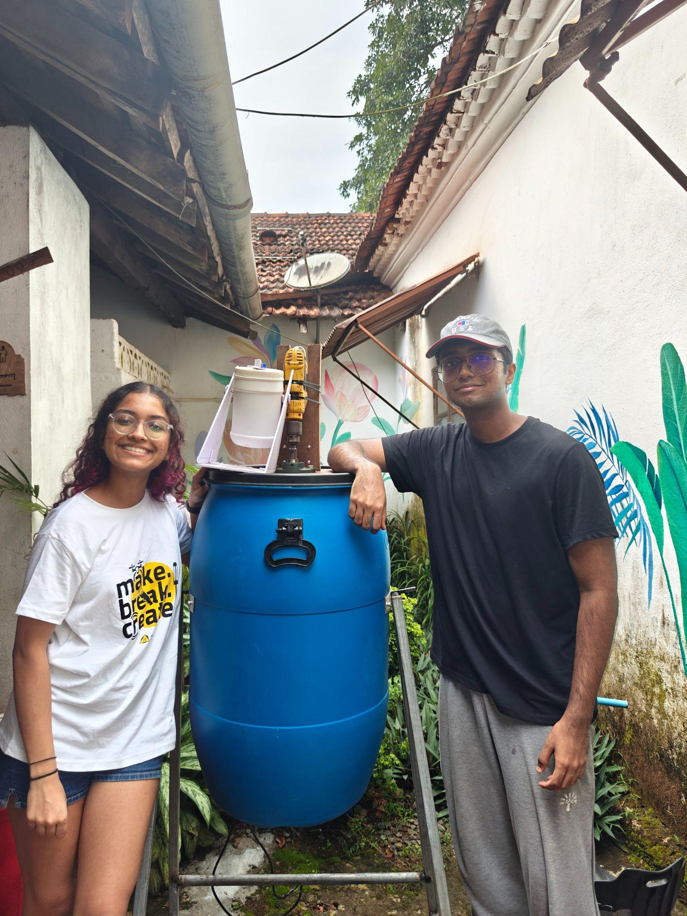

(The final Compost-Drill along with its 3rd prototype)

Attached below are some pictures of the process of the making of ‘THE COMPOST-DRILL’

